17
RENAISSANCE AND BAROQUE EUROPE
THINK AHEAD
17.1 ExplaintheconceptofhumanismanditsimpactonRenaissanceartandculture.
17.2 Contrastthetechniques,media,andthemesinItalianandNorthernEuropeanartoftheRenaissance. 17.3 DescribehowsocialandreligiouseventsoftheseventeenthcenturyshapedBaroqueart.
17.4 ComparestylisticcharacteristicsofRenaissance,Baroque,andRococoart.
17.5 RecognizetherelationshipofRococoarttotheFrencharistocracy.
17.6 Discussexamplesofartthatfunctiontopersuadeorinfluencetheviewer.
Many works generally regarded as masterpieces were created during the Renaissance, when ambitious artists combined technical advances with profound subject matter to create works that still resonate today. Then in the Baroque period, an exceptionally dynamic time in Western history, artists expanded the means of producing works of art and their subject matter. The Rococo period that followed was a more decorative and playful elaboration of the Baroque style. Many techniques and attitudes developed in the Renaissance and Baroque remained in force until the twentieth century.
The Renaissance
A shift in attitude occurred in Europe as the religious fervor of the Middle Ages was increasingly chal- lenged by logical thought and the new philosophi- cal, literary, and artistic movement called humanism. Leading humanist scholars did not discard theologi- cal concerns, yet they supported the secular dimen- sions of life, pursued intellectual and scientific inquiry, and rediscovered the classical culture of Greece and Rome. Humanist thought gives most importance to human rather than to divine or supernatural mat-
Listen to the chapter audio on myartslab.com
ters. Humanists stress the potential value and ability of humans, using their God-given wisdom, to solve problems, and they seek rational solutions rather than divinely inspired ones.
The cultural focus gradually shifted from God and the hereafter to humankind and the here and now. For many Europeans, the Renaissance was a period of achievement and worldwide exploration—a time of discovery and rediscovery of the world and of the seem- ingly limitless potential of individual human beings. The period was foreshadowed in the fourteenth cen- tury, reached its clear beginning in the early fifteenth century, and came to an end in the early seventeenth century. However, Renaissance thinking continues to influence our lives today, not only in Western countries but in all parts of the world where individualism, mod- ern science, and technology influence the way people live. In art, new and more scientific approaches were brought to the quest for representational accuracy. The resulting naturalism defined the Western tradition for more than four hundred years.
The intellectuals of the time were the first in European history to give their own era an identifying name. They named their period the Renaissance—lit- erally, “Rebirth”—an apt description for the period of revived interest in the art and ideas of classical
RENAISSANCE AND BAROQUE EUROPE CHAPTER 17 279
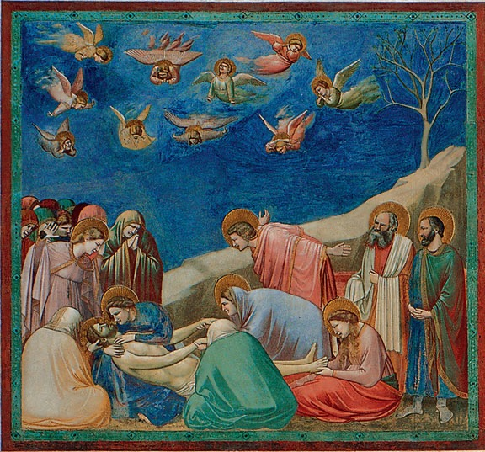
17.1 Giotto di Bondone. Lamentation. Scrovegni Chapel, Padua, Italy. c.1305. Fresco. 72 ̋ × 78 ̋.
© Studio Fotografico Quattrone, Florence.
View the Closer Look for the technique of fresco on myartslab.com
Greece and Rome. Fifteenth-century Italians believed they were responsible for the rebirth of “the glory of ancient Greece,” which they considered the high point of Western civilization. Yet Greco-Roman culture was not totally reborn, because this “classical” heritage had never truly disappeared from the medieval West. Muslim scholars in Spain, Egypt, and Iraq maintained respect for the Greeks and translated their works into Arabic for their libraries. Muslim and European scholars of the thirteenth and fourteenth centuries then recovered these works and made them available in Latin. In essence, the Renaissance was a period of new and renewed understanding that transformed the medieval European world, and laid the foundation for modern society.
New values combined with technological advances brought forth a new style of art in the four- teenth century. Painting and sculpture were liberated from their medieval roles as supplements to architec- ture. Artists, who considered themselves anonymous workers in the Middle Ages, came to be seen as indi- viduals of creative genius.
The art of the Renaissance evolved in different ways in northern and south- ern Europe because the people of the two regions had different backgrounds, attitudes, and experiences. The Gothic style reached its high point in the north while Byzantine and Greco-Roman influences remained strong in the south. Italian Renaissance art grew from classical Mediterranean tradi- tions that were human-centered and often emphasized the ideal. In contrast, the art of the northern Renaissance evolved out of pre- Christian, nature-centered religions that had become God-centered through conversion to Christianity.
We see the beginnings of the new humanistic art in Italian painter Giotto di Bondone, known as Giotto. He departed
from the abstract, Byzantine style by portraying the feelings and physical nature of human beings. His innovative depictions of light, space, and mass gave a new sense of realism to painting. In Lamentation (fig. 17.1), Giotto depicted physical as well as spiritual reality. His figures are shown as individuals within a shallow, stagelike space, and their expressions portray personal feelings of grief rarely seen in medieval art.
In retrospect, Giotto is considered not only a precursor of the Renaissance, but also the reinventor of naturalistic painting, which had not been seen in Europe since the decline of Rome a thousand years earlier. This “realism” is still an important current in Western painting.
The ancient Greeks had been concerned with ide- alized physical form; Roman artists had emphasized physical accuracy; and artists of the Middle Ages had focused on spiritual concerns rather than physical exis- tence. In the Renaissance, as attention shifted from heaven to earth, artists portrayed Christian subjects in human terms. Italian civic leaders expressed a desire to equal or surpass the glory of ancient Greece and Rome and to imbue their achievements with the light of Christian understanding.
Italy was the principal homeland of the Renaissance. In time the movement spread northward, but it did not flourish everywhere in Europe; it came late to Spain and Portugal, and it barely touched Scandinavia.
280 CHAPTER 17 RENAISSANCE AND BAROQUE EUROPE
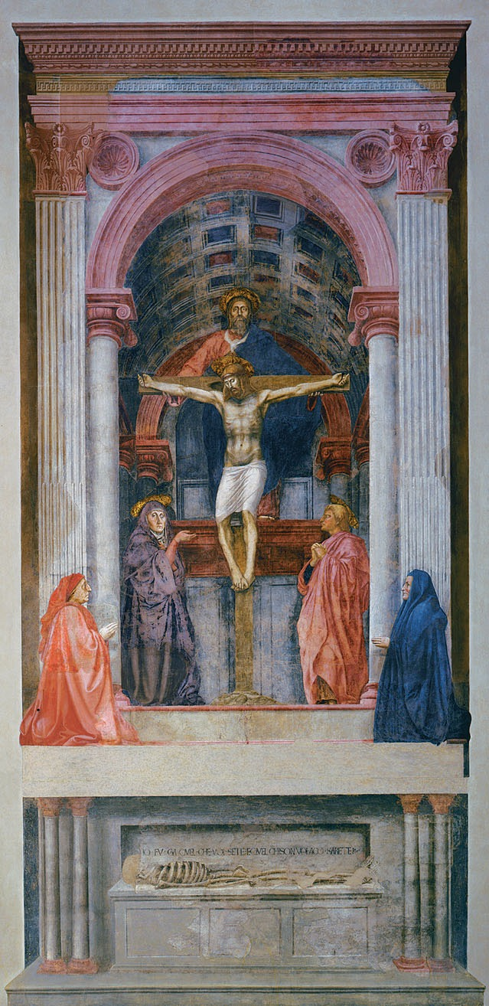
The Renaissance in Italy
Artistic and intellectual developments in the Italian city-states were aided by a flourishing economy set against a chaotic political back- ground. The wealth of Italian merchants enabled them to compete with one another, and with church officials and nobility, for the recognition and power that came with art patronage.
Italian architects, sculptors, and painters sought to integrate Christian spiritual tradi- tions with the rational ordering of physical life in earthly space. Artists began an intense study of anatomy and light, and they applied geometry to the logical construction of implied space through the use of linear per- spective (see Chapter 3). In turn, the careful observation of nature initiated by Renaissance artists aided the growth of science.
About one hundred years after Giotto, Masaccio became the first major painter of the Italian Renaissance. In his fresco The Holy Trinity (fig. 17.2), the composition is centered on an open chapel in which we see the Trinity: God the father, Christ the son, and between their heads a white dove symbolizing the Holy Spirit. Within the niche, Mary the mother of Jesus stands, gesturing to Christ; opposite her is St. John. Kneeling outside are the donors who paid for the painting, a husband and wife who headed a powerful banking family of that time. He is wearing the red robe that marks him as a member of the Florence city coun- cil. Below, a skeleton lies on a sarcophagus beneath the inscription, “I was what you are, and what I am, you shall become.” If we view the painting from top to bottom, we move from the spiritual to the physical.
The Holy Trinity was the first painting based on the systematic use of linear per- spective. Although perspective was known to the Romans in a limited way, it did not become a consistent science until architect Filippo Brunelleschi rediscovered and devel- oped it in Florence early in the fifteenth cen- tury. Masaccio used perspective to construct
17.2 Masaccio. The Holy Trinity. Santa Maria Novella, Florence, Italy. 1425. Fresco. 21 ́101⁄2 ̋ × 10 ́5 ̋. © Studio Fotografico Quattrone, Florence.
RENAISSANCE AND BAROQUE EUROPE CHAPTER 17 281
an illusion of figures in three-dimensional space. The single vanishing point is below the base of the cross, about 5 feet above ground, at the viewer’s eye level. Masaccio’s perspective is so precise that we can see the interior of the illusionary chapel as a believable exten- sion of the space we occupy. The setting also reveals Masaccio’s knowledge of the new Renaissance archi- tecture developed by Brunelleschi, which he based on Roman prototypes.
The figures in The Holy Trinity have a physi- cal presence that shows what Masaccio learned from the work of Giotto. In Giotto’s work, however, body and drapery still appear as one; Masaccio’s figures are clothed nudes, with garments draped like real fabric.
During the Italian Renaissance, the nude became a major subject for art, as it had been in Greece and Rome. Unclothed subjects are rare in medieval art and appear awkward, their bodies graceless. In contrast, sculpted and painted figures by Italian Renaissance artists appear as strong and natural as the Greek and Roman nudes that inspired them.
As Masaccio innovated in painting, Donatello did in sculpture. Donatello brought the Greek ideal of what it means to be human into the Christian context. As a young adult, he made two trips to Rome, where he studied medieval and
Roman art.
Donatello shows himself as an
ambitious artist even in his early work. His bronze figure David (fig. 17.3) was the first life- size, freestanding nude statue since ancient Roman times. To Florence, where the work was located, David was not only a biblical figure; his resis- tance to foreign domination of the Jews inspired the Florentines, who were surrounded by stronger enemy cities.
17.3 Donatello. David. c.1425–1430.
Bronze. Height 621⁄4 ̋.
Museo Nazionale del Bargello, Florence.
© Studio Fotografico Quattrone, Florence.
Although he was greatly attracted to the classical ideal in art, Donatello’s sculpture was less idealized and more naturalistic than that of ancient Greece. He chose to portray the biblical shepherd, David—slayer of the giant Goliath and later king of the Jews—as an adolescent youth rather than as a robust young man. The sculptor celebrated the sensuality of the boy’s body by clothing him only in hat and boots. Every shift in the figure’s weight and pose is expressive. The youth’s position is derived from classical contrapposto. The few nudes that appeared in medieval art showed little sensual appeal and often portrayed shame and lust. Under the influence of humanist scholars who sought to surpass the Greeks and Romans in the nobility of form, the nude became a symbol of human worth and divine perfection, a representation of the “immortal soul.”
During the Renaissance, artists received growing support from the new class of wealthy merchants and bankers, such as the Medici family, who, with great political skill and a certain ruthlessness, dominated the life of Florence and Tuscany. It is likely that Donatello created his bronze David as a private com-
mission for Cosimo de’ Medici, for the
courtyard of the Medici palace.
A major influence on Donatello and other Renaissance artists was the renewal of Neoplatonist philosophy, embraced by the Medici family and their circle of humanist philoso- phers, artists, and historians. These intellectuals believed that all sources
of inspiration or revelation, whether from the Bible or classical mythol- ogy, are a means of ascending from earthly existence to mystical union with the divine. In this context, Donatello’s David was intended to
be a symbol of divine beauty.
17.4 Donatello. Mary Magdalene. c.1455. Wood, partially gilded. Height 74 ̋.
Photo Scala, Florence/Fondo Edifici di Culto—Min. dell’Interno.
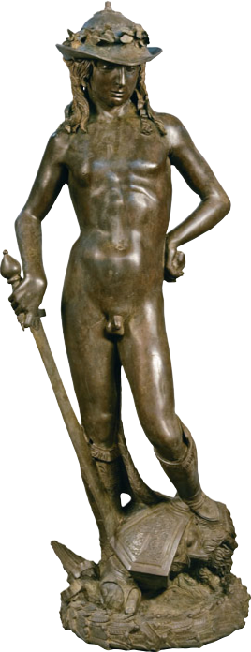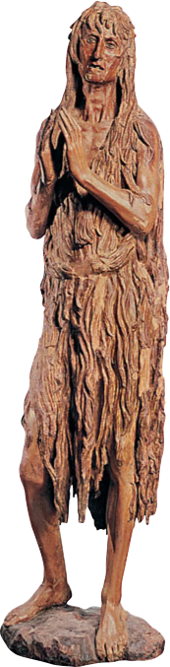
282 CHAPTER 17
RENAISSANCE AND BAROQUE EUROPE
Donatello’s work displayed a wide range of expres- sion, from lyric joy to tragedy. In contrast to the youthful and somewhat brash David, Donatello’s Mary Magdalene (fig. 17.4) is haggard and withdrawn—a forcefully expressive figure of old age and repentance. For this late work, Donatello chose painted wood, the favorite medium of northern Gothic sculptors.
Another Medici commission is Sandro Botticelli’s Birth of Venus (fig. 17.5), the first large mythologi- cal painting since antiquity. Completed about 1480, this work depicts the Roman goddess of love just after she was born from the sea. She is blown to shore by a couple symbolizing the wind. As she arrives, Venus is greeted by a young woman who represents Spring. The lyric grace of Botticelli’s lines shows Byzantine influ- ence. The background is decorative and flat, giving almost no illusion of deep space. The figures appear to
be in relief, not fully three-dimensional. Botticelli and his Medici patrons believed that an artwork need not be Christian to be uplifing and beautiful.
The posture and gestures of modesty were proba- bly inspired by the classical Venus statue that Botticelli must have seen in the Medici family collection (see fig. 16.5). In her posture of introspection and repose, Botticelli’s Venus combines the classical Greek ideal- ized human figure with a Renaissance concern for thought and feeling.
To place a nude “pagan” goddess at the center of a large painting, in a position previously reserved for the Virgin Mary, was novel. Botticelli’s focus on classical mythology was, like Donatello’s, based on Neoplatonist philosophy, a central preoccupation of the business-oriented, secular art patrons who com- missioned most Renaissance art.
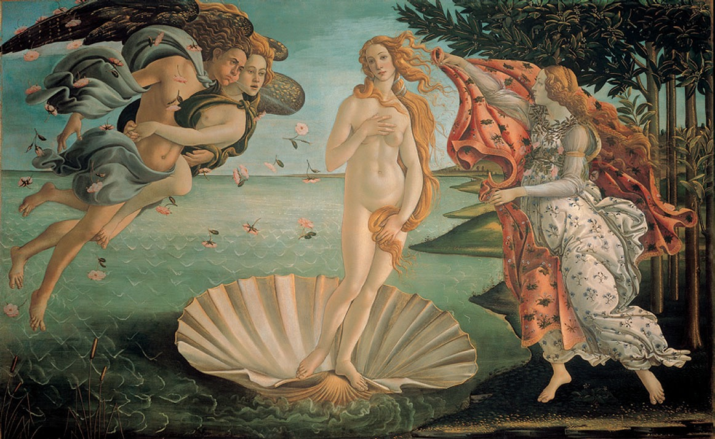
17.5 Sandro Botticelli. Birth of Venus. c.1480. Tempera on canvas. 5 ́87⁄8 ̋ × 9 ́17⁄8 ̋. Uffizi Gallery, Florence, Italy. © Studio Fotografico Quattrone, Florence.
RENAISSANCE AND BAROQUE EUROPE CHAPTER 17 283
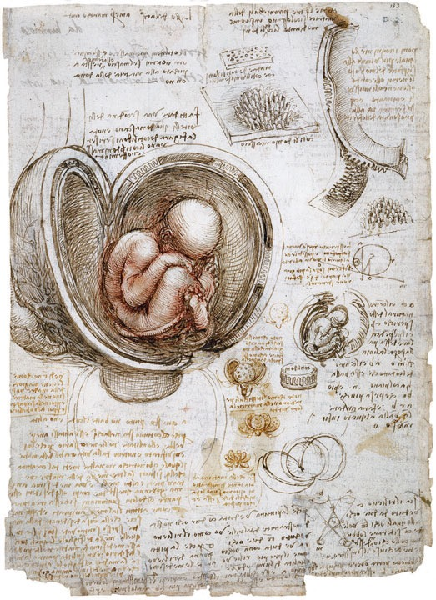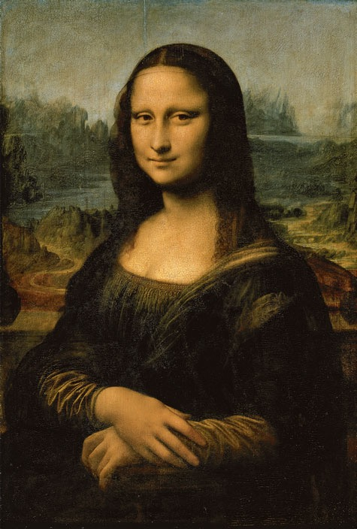
The High Renaissance
Between about 1490 and 1530—the period known as the High Renaissance—Italian art reached a peak of accomplishment in the cities of Florence, Rome, and Venice. The three artists who epitomized the period were Leonardo da Vinci, Michelangelo Buonarroti, and Raffaello Sanzio (Raphael). They developed a style of art that was calm, balanced, and idealized, combin- ing Christian theology with Greek philosophy and the science of the day.
Leonardo was motivated by strong curiosity and belief in the human ability to understand the fascinating phenomena of the physical world. He believed that art and science are two means to the same end: knowledge.
Leonardo showed his investigative and creative mind in his journals, where he documented his research in notes and drawings (see also fig. 6.2). His notebooks are filled with studies of anatomy and ideas for mechanical devices, explorations that put him at the forefront of the scientific development of
17.6 Leonardo da Vinci. The Fetus in the Womb. c.1510. Pen and ink. 117⁄8 ̋ × 83⁄8 ̋.
The Royal Collection © 2013 Her Majesty Queen Elizabeth II/ The Bridgeman Art Library.
his time. His study The Fetus in the Womb (fig. 17.6) has a few errors, yet much of the drawing is so accu- rate that it could serve as an example in one of today’s medical textbooks.
So frequently has Leonardo’s world-famous por- trait Mona Lisa (fig. 17.7) been reproduced that it has become a cliché and the source of innumer- able spoofs. Despite this overexposure, it still mer- its our attention as an expression of Renaissance ideas. We can still be intrigued by the mysterious
17.7 Leonardo da Vinci. Mona Lisa. c.1503–1506. Oil on wood. 301⁄4 ̋ × 21 ̋.
Musée du Louvre, Paris, France. RMN/Michel Urtado.
View the Closer Look for the Mona Lisa on myartslab.com
284 CHAPTER 17 RENAISSANCE AND BAROQUE EUROPE
mood evoked by the faint smile and the strange, otherworldly landscape. The ambiguity is height- ened by the hazy light quality that gives a sense of atmosphere around the figure. This soft blurring of the edges—in Leonardo’s words, “without lines or borders in the manner of smoke”1—achieved through subtle value gradations, is a special type of chiaroscuro invented by Leonardo. Most important for the history of art, this work is a portrait of an individual, a type of art fairly common in ancient Rome and almost unknown in the medieval period.
Humanism influenced the belief that an individual could be worthy of a portrait.
The impact of Renaissance humanism becomes apparent when we compare The Last Supper by Leonardo (fig. 17.8) with the Byzantine mosaic Christ as Pantocrator (see fig. 16.18). In the Byzantine work, Christ is portrayed as a lofty being of infinite power, the King of Heaven. In Leonardo’s painting, Jesus sits across the table from us—an accessible person who reveals his divinity in an earthly setting, among disci- ples who look like us.
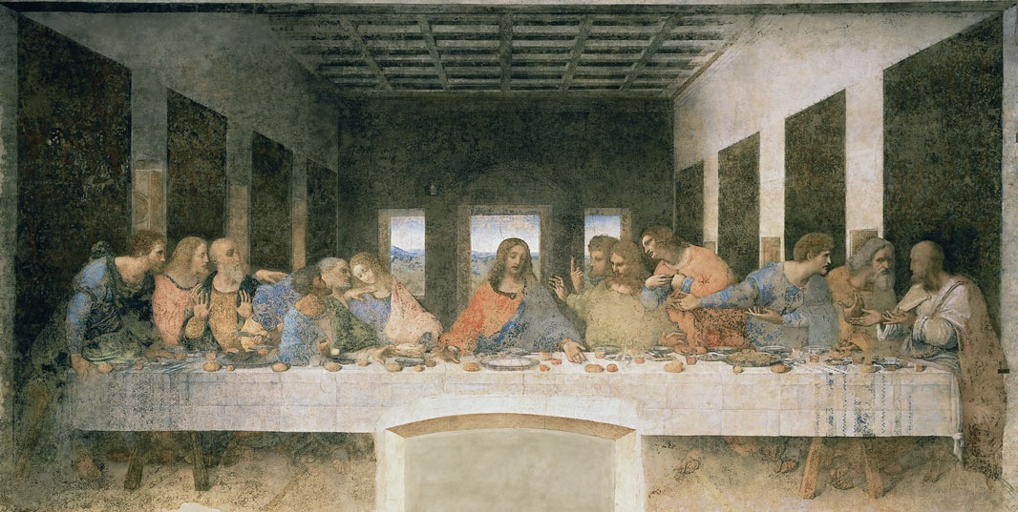
17.8 Leonardo da Vinci. The Last Supper. Santa Maria delle Grazie, Milan, Italy. c.1495–1498. Experimental paint on plaster. 14 ́5 ̋ × 28 ́1⁄4 ̋.
© Studio Fotografico Quattrone, Florence.
a. Perspective lines as both organizing b. Christ’s figure as stable triangle, contrasting structure and symbol of content. with active turmoil of the disciples.
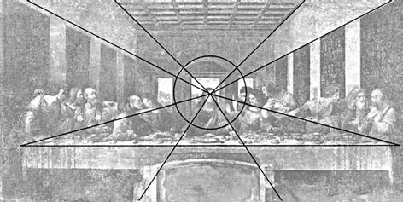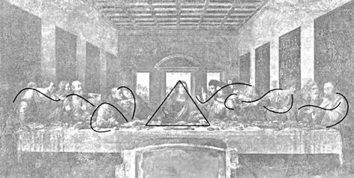
RENAISSANCE AND BAROQUE EUROPE
CHAPTER 17 285
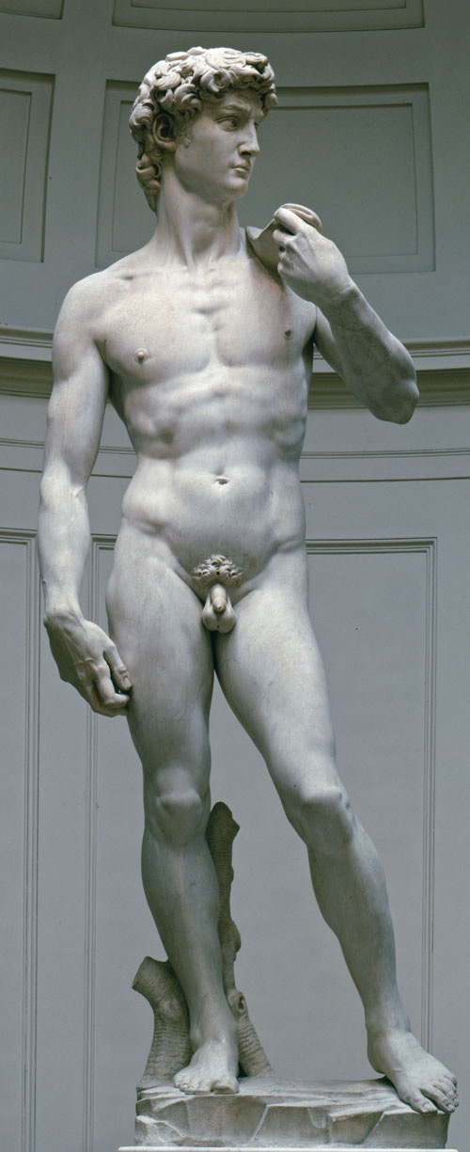
17.9 Michelangelo Buonarroti. David. 1501–1504. Marble. Height of figure 14 ́3 ̋.
Accademia, Florence. Photograph © Studio Fotografico Quattrone, Florence.
Watch a podcast comparing the statues of David by Michelangelo and Bernini on myartslab.com
The naturalist style of the work contains a hidden geometry, which structures the design and strengthens the painting’s symbolic content. The interior is based on a one-point linear perspective system, with a single vanish- ing point in the middle of the composition, behind the head of Christ. Leonardo placed Christ in the center, at the point of greatest implied depth, associating him with infinity. Over Christ’s head an architectural pediment suggests a halo, further setting him off from the irregular shapes and movements of the surprised disciples on either side. In contrast to the anguished figures surrounding him, Christ is shown with his arms outstretched in a gesture of acceptance, his image a stable triangle.
Like The Last Supper, Michelangelo’s David (fig. 17.9) is an important work that expresses many Renaissance ideas. The biblical hero David was an important sym- bol of freedom from tyranny for Florence, which had just become a republic. Other Renaissance artists such as Donatello had already given the city images of the young David, but Michelangelo’s figure gave the most powerful expression to the idea of David as hero, the defender of a just cause.
Michelangelo took David’s stance, with the weight of the body on one foot, from the contrapposto of Greek sculpture. But the positions of the hands and tense frown indicate anxiety and readiness for conflict. Through changes in proportion and the depiction of inner feeling, Michelangelo humanized, then made monumental, the classical Greek athlete.
Michelangelo worked for three years on this sculpture. When it was finished and placed in the town square, most citizens of Florence greeted it with approval. With this achievement, Michelangelo became known as the greatest sculptor since the Greeks.
When Pope Julius II decided to redecorate the ceil- ing of his private prayer chapel, he begged, cajoled, and eventually ordered the unwilling sculptor to take on the painting commission. Michelangelo began work on the Sistine Chapel ceiling (fig. 17.10a) in 1508 and finished it four years later. The surface is divided into three zones. In the highest are nine panels of scenes of the creation of the world from Genesis, including The Creation of Adam. The next level contains prophets and sibyls (female proph- ets). The lowest level consists of groups of Old Testament figures, some of them Christ’s biblical ancestors. The Last Judgment, painted later, fills the end wall above the altar.
286 CHAPTER 17 RENAISSANCE AND BAROQUE EUROPE
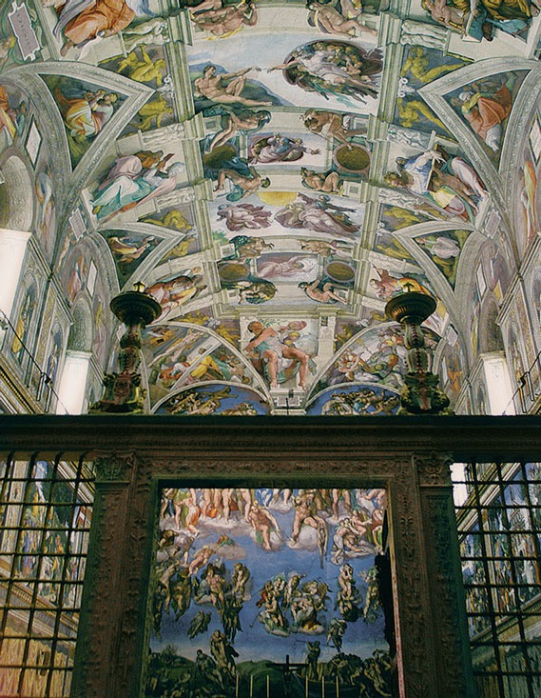
The most-admired composition on the ceiling is the majestic Creation of Adam (fig. 17.10b), in which God reaches out to give life to the first man. Eve, not yet mortal, stares at Adam from behind God’s left arm.
The work powerfully expresses the Renaissance humanist concept of God: an idealized, rational man who actively tends every aspect of creation, and has a special interest in humans. Michelangelo invented this powerful image, which does not exist in the Bible, to tell the story of the relationship between God and people from a Renaissance point of view.
Raphael was the third major artist of the High Renaissance. His warmth and gentleness were in sharp contrast to Leonardo’s solitary, intellectual nature and Michelangelo’s formidable moodiness. Of these three major creators, Raphael’s work most frequently embodied the clarity and balance that marked the art of the period. His paintings present his awareness of the divine in human beings, the insight that was the driving enthusiasm of the Italian Renaissance.
In The School of Athens (see fig. 3.22), we see one of the clearest summations of Renaissance beliefs. Raphael organized the complex composition into symmetrical sub-groups, all revolving around the central figures of Plato and Aristotle under the arch. Perspective lines help to frame our focus on them. Most of the figure poses in this work are based in
17.10 Michelangelo Buonarroti. Frescoes on the ceiling of the Sistine Chapel. Vatican, Rome. 1508–1512.
a. The Sistine Chapel.
Vatican Museums, Rome, Italy. © Reuters/Corbis.
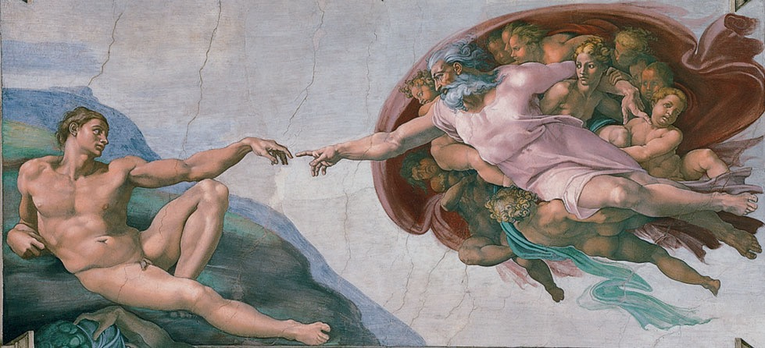
b. The Creation of Adam. Vatican Museums, Rome, Italy.
RENAISSANCE AND BAROQUE EUROPE
CHAPTER 17 287
classical antiquity. More important, The School of Athens elevates human reason by presenting a philo- sophical discussion among learned people as an ideal. The Pope commissioned this work for the wall of a meeting room, so that persons discussing Church business could be inspired by an ideal meeting of great people from the past. Rarely has humanism been so clearly expressed.
For Pope Leo X (a Medici descendant), Raphael made a series of cartoons for tapestries that would decorate the walls of the Sistine Chapel, below Michelangelo’s ceiling. The tapestries have faded, but the cartoons retain most of the original vivid colors (fig. 17.11). Leo wished to glorify the early Church by commissioning illustrations of important events in the Acts of the Apostles, and Raphael responded by creating memorable and dramatic works. Paul Preaching at Athens is a diverse yet well-organized composition, as Paul preaches to the philosophically inclined Athenians. Among the audience is Pope Leo, just to the left of Paul. The message of this work, that reason can transmit religious truth, perfectly expresses Renaissance beliefs.
The Renaissance in Northern Europe
As the Early Renaissance was unfolding in Italy, a par- allel new interest in realism arose in northern Europe, where artists were even more concerned than the Italians with depicting life in the real world. Jan van Eyck was a leading painter in Flanders, the region of present-day Belgium and adjacent parts of France and the Netherlands. He was one of the first to use oil as a painting medium (see also fig. 7.11). The fine con- sistency and flexibility of the new oil medium made possible a brilliance and transparency of color that were previously unattainable. His oil paintings remain in almost perfect condition, attesting to his skill and knowledge of materials. Later Italian artists admired and imitated the innovations of van Eyck and other Flemish artists.
On the same type of small wooden panels previ- ously used for tempera painting, van Eyck painted in minute detail, achieving an illusion of depth, directional light, mass, rich implied textures, and the physical likenesses of particular people. Human fig- ures and their interior settings took on a new, believ- able presence.
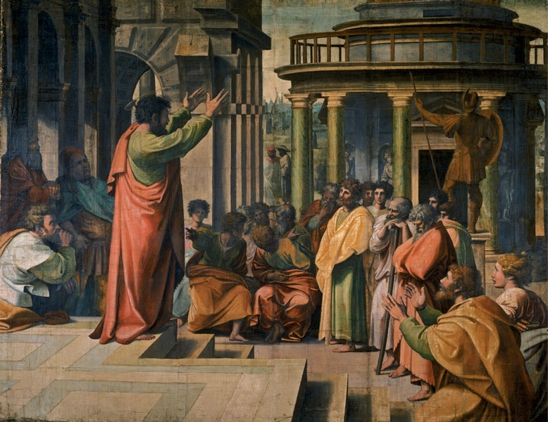
288 CHAPTER 17
RENAISSANCE AND BAROQUE EUROPE
17.11 Raphael.
Paul Preaching at Athens.
1515–1516. Watercolor on paper mounted on canvas.
11 ́51⁄2 ̋ × 14 ́63⁄4 ̋.
Victoria and Albert Museum, London © V&A Images/The Royal Collection, on loan from HM The Queen.
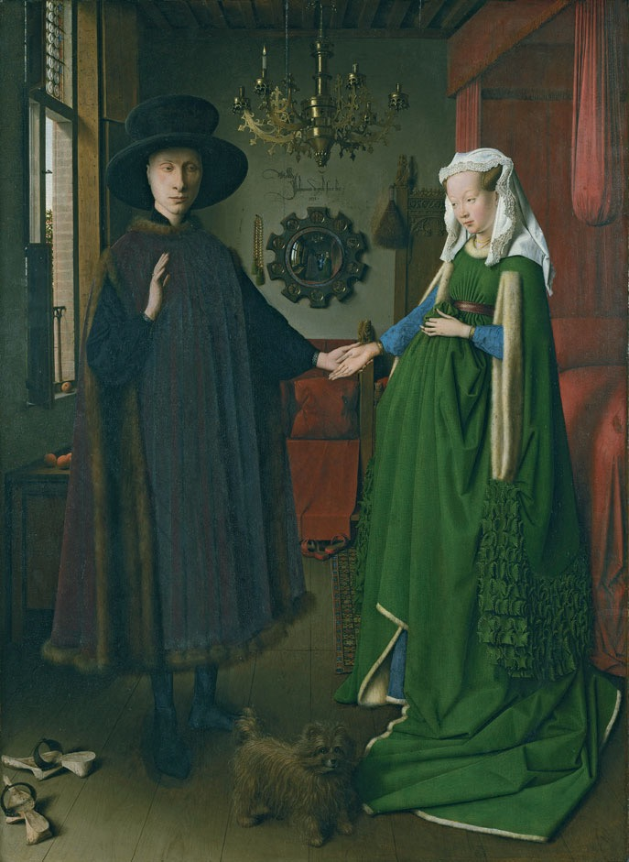
17.12 Jan van Eyck. The Arnolfini Portrait.
1434. Oil on panel. 331⁄2 ̋ × 231⁄2 ̋.
© 2013. Copyright The National Gallery, London/ Scala, Florence.
View the Closer Look for The Arnolfini Portrait on myartslab.com
His most famous work, The
Arnolfini Portrait (fig. 17.12), is also
among the most puzzling. It likely com-
memorates a wedding or a betrothal,
though because the identity of the peo-
ple is in question, we may never know.
Many of the ordinary objects portrayed
with great care have sacred significance.
The single lighted candle in the chan-
delier symbolizes the presence of Christ;
the amber beads and the sunlight shin-
ing through them are symbols of purity;
the dog indicates marital fidelity. The
bride’s holding up her skirt suggestively
in front of her stomach may indicate
her willingness to bear children. Green,
a symbol of fertility, was often worn at
weddings. As witness to the event, Jan
van Eyck placed his signature and the
date, 1434, directly above the mirror—
and he himself appears reflected in the
mirror (see fig. 3.54). What makes this
a Renaissance work is the fact that it seems to take place in the next room, the figures and the space are so accurately captured. The concept of a painting as a window into a world similar to ours originated with works such as this.
In the early sixteenth century in Germany, Albrecht Dürer further developed the practice of com- bining instructive symbolism with detailed realism. His engraving The Knight, Death, and the Devil (see fig. 8.10) combines Christian symbols with familiar subjects in the Flemish tradition of van Eyck.
A major factor that conditioned art production in northern Europe was the Protestant Reformation, which began in approximately 1521 when Pope Leo X excommunicated the rebellious monk Martin Luther
from the Roman Catholic Church. Clergy allied with the burgeoning Protestant movement discouraged elaborate church interiors, and this led to a sharp drop in commissions for altarpieces and religious decora- tions. Therefore, a great deal of Renaissance art in the North was destined for private possession in homes.
Pieter Bruegel developed a new artistic vision of the northern European landscape. As a young man, he traveled extensively in France and Italy. Under the influence of Italian Renaissance painting, Bruegel developed a broad sense of composition and spatial depth. The focus of Bruegel’s paintings was the lives and surroundings of common people. Such works that depict everyday life are still beloved today and are called genre paintings.
RENAISSANCE AND BAROQUE EUROPE CHAPTER 17 289
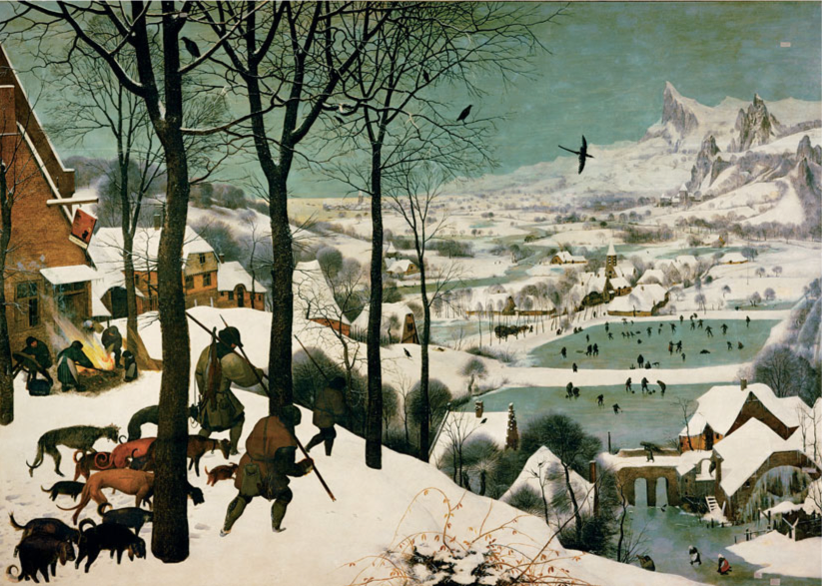
Toward the end of his life, Bruegel did a series of paintings representing the activities of the 12 months of the year. The work corresponding to January, Hunters in the Snow (fig. 17.13), is among the most highly regarded. Following the precedent set by manuscript painters (illuminators) of medieval calendars, who depicted each month according to the agricultural labor appropriate to it, Bruegel shows peasants augmenting their winter diet by hunting. New here is the emphasis on nature’s winter mood rather than on human activ- ity. The heavy steps of the hunters are extended in the row of trees and the frozen ponds in the distance. The illusion of deep space, so important to this image, came from the innovations of the Italians and was also inspired by Bruegel’s journey over the Alps.
Late Renaissance in Italy
During the later sixteenth century, architects made a deliberate effort to rethink and extend classical rules even as they used classical forms. The most learned and influential architect was the Venetian Andrea Palladio. His famous Villa Rotonda (fig. 17.14) is a free reinterpretation of the Roman Pantheon (see fig. 16.10). It has four identical sides, complete with porches resembling ancient temple façades, built around a central domed hall. The villa’s design hardly
satisfies the architectural goal of livability, but it was not intended for family living; it was designed for a retired nobleman as a kind of open summer house for social occasions. From its hilltop site, visitors standing in the central rotunda could enjoy four different views of the countryside.
Palladio’s designs were published in books that were widely circulated throughout the Western world. For the next two centuries, architects and builders from Russia to Pennsylvania often used motifs that he developed, and his designs have even reappeared on postmodern buildings in our generation.
Palladio’s Venice became the scene of the last great flowering of Renaissance art. Using the newly developed oil paints on canvas supports, Venetian painters experimented with figure poses, composi- tions, and subjects. Responding to a clientele made wealthy from trading across the Mediterranean world, Venetian painting was rich and lavish, less idealized than the work of central Italian artists such as Raphael and Michelangelo.
We see an example of Venetian opulence in one of its most celebrated paintings, Feast in the House of Levi (fig. 17.15) by Paolo Veronese. This large work depicts a sumptuous banquet described in the New Testament that Jesus attended (we see him seated at the center).
290 CHAPTER 17 RENAISSANCE AND BAROQUE EUROPE
17.13 Pieter Bruegel. Hunters in the Snow.
1565. Oil on panel. 461⁄2 ̋ × 633⁄4 ̋.
Kunsthistorisches Museum, Vienna, Austria. akg images/ Erich Lessing.
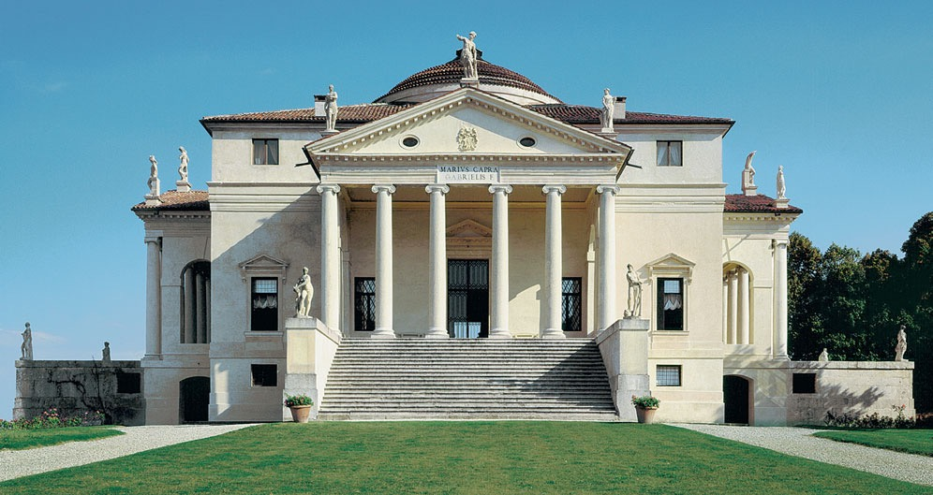
17.14 Andrea Palladio. Villa Rotonda. Vicenza, Italy. 1567–1570. Cameraphoto/AKG Images.
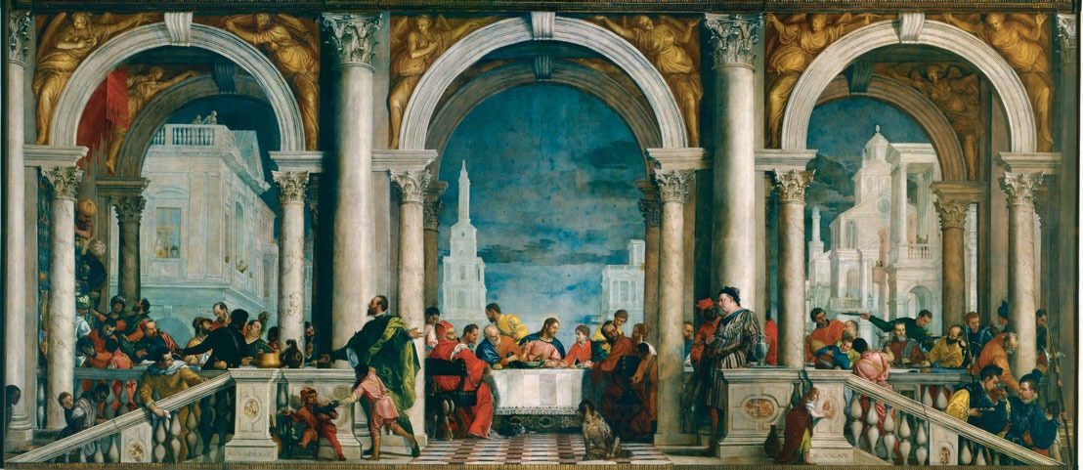
17.15 Paolo Veronese. Feast in the House of Levi. 1573. Oil on canvas. 18 ́4 ̋ × 16 ́7 ̋. Accademia Gallery, Venice/© Cameraphoto Arte, Venice.
The artist set the scene under a Venetian arcade, using features borrowed from Palladio’s buildings. Servants rush about, waiting on persons of various nationali- ties (including a German in stripes at the right center). Not everyone in the work is sober. The atmosphere is one of elegant yet boisterous wealth.
Today, the work is called Feast in the House of Levi, but it was commissioned by the monks of a monas- tery for their dining hall as a Last Supper. Veronese took such liberties with the traditional subject of Christ’s bidding farewell to his disciples (compare to Leonardo’s Last Supper), that the religious authorities
RENAISSANCE AND BAROQUE EUROPE CHAPTER 17 291
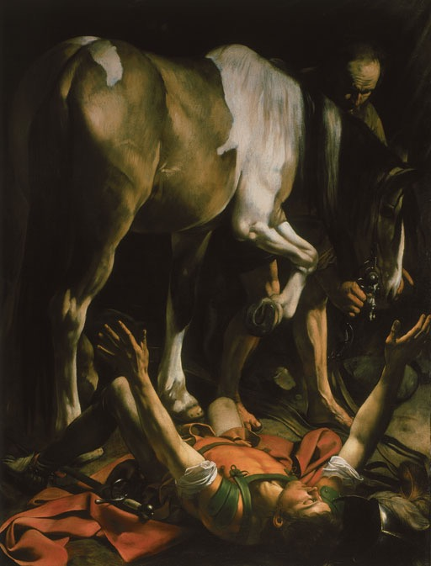
suspected the artist of impiety or heresy. They called him before the Inquisition, the tribunal where such cases were heard. This led to one of the first impor- tant trials of artistic freedom in the Western world.
Why, they asked Veronese, did he include depictions of “buffoons, drunkards, Germans, dwarfs, and similar vulgarities” when none were present at the actual Last Supper? The artist’s defense was one that most Western artists have eagerly embraced ever since: The artist should be free to interpret subjects as he wishes. Or, as Veronese said: “I paint pictures as I see fit and as well as my talent permits.”2 The Inquisitors ordered him to alter the painting and bring it more in line with what viewers of a Last Supper could expect. But instead of changing the work, the art- ist merely retitled it to reflect the lively party in the house of Levi. The controversy had no discern- ible impact on Veronese’s reputation in otherwise liberal-minded Venice.
Baroque
During the Baroque period, which ran from about 1600 to about 1750, artists used Renaissance tech- niques to move art in the direction of drama, emotion, and splendor. The Baroque period had more varied styles than the Renaissance, yet much of the art shows great energy and feeling, and a dramatic use of light, scale, and composition. Baroque artists set aside the balanced harmony achieved by Renaissance artists such as Raphael in his School of Athens and Michelangelo in his David, as they explored more innovative uses of space and more intense ranges of light and shadow. Their art, with its frequent use of curves and counter- curves, often appeals to the emotions first. Also, we can see a new degree of vivid realism in compositions using sharp diagonals and extreme foreshortening.
Many of the characteristics of the Baroque style were spawned and promoted by the Counter-Reformation, the Roman Catholic Church’s response to the Protestant Reformation. In a series of decrees that emanated from the Council of Trent, the Church reaffirmed the mysteries of the sacraments, glorified the saints, and encouraged the arts as aids to prayer. Much Baroque religious art places a new emphasis on personal and mystical types of faith.
17.16 Michelangelo Merisi da Caravaggio. The Conversion of Saint Paul. 1600–1601. Oil on canvas. 1001⁄2 ̋ × 69 ̋. Santa Maria del Popolo, Rome, Italy. © Vincenzo Pirozzi, Rome.
Michelangelo Merisi da Caravaggio’s down-to- earth realism and dramatic use of light broke from Renaissance idealism and became the leading influ- ences on other Baroque painters, north and south. Caravaggio created the most vivid and dramatic paint- ings of his time, using directed light and strong con- trasts to guide the attention of the viewer and intensify the subject matter.
In The Conversion of Saint Paul (fig. 17.16), Caravaggio used light to imply a blinding flash, sym- bolizing the evangelist’s sudden and soul-shattering conversion. The figure of Paul, in Roman dress, is foreshortened and pushed into the foreground, pre- senting such a close view that we feel we are right there. In keeping with the supernatural character of the spiritual events he portrayed, Caravaggio evoked a feeling for the mystical dimension within the ordi- nary world. Here we see a Baroque figure far removed from Raphael’s logical, reasonable Paul who preached at Athens. Some of the Roman clergy rejected his style; his emotional realism was too strong for people
292 CHAPTER 17 RENAISSANCE AND BAROQUE EUROPE
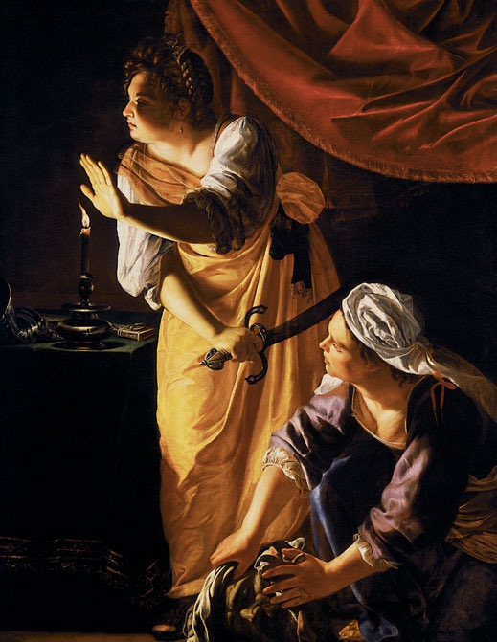
accustomed to idealized aristocratic images that dem- onstrated little more than gestures of piety.
Emotional realism and use of extreme chiaroscuro, especially in Caravaggio’s night effects, influenced later Baroque painters. Displayed in a dark chapel, Caravaggio’s paintings take on a vivid, lifelike quality intended to heighten the religious experience.
We see an example of Caravaggio’s influence in the work of Artemisia Gentileschi, who turned the style toward depiction of female religious heroes. Judith and the Maidservant with the Head of Holofernes (fig. 17.17) is a scene from the Old Testament story of Judith, who helped to liberate the Jews from for- eign domination by visiting the Assyrian general Holofernes in his tent, getting him drunk, and then beheading him. This work shows Judith and her ser- vant cleaning up the scene as they wrap their victim’s severed head in a towel. According to the story, they then carried the head back to their people and dis- played it as a symbol of resistence. The dramatic light- ing, off-balance composition, and sweeping curves in
17.17 Artemisia Gentileschi. Judith and the Maidservant with the Head of Holofernes. c.1625.
Oil on canvas. 6 ́1⁄2 ̋ × 4 ́73⁄4 ̋. Detroit Institute of Art Gift of Mrs. Leslie H. Green.
Photogrpah © The Detroit Institute of Arts/The Bridgeman Art Library.
bodies and draperies mark this as a particularly dra- matic, even lurid, example of the Baroque style. The artist portrayed Judith with many of her own features, showing that she identified with the heroine.
Gianlorenzo Bernini was as influential in sculp- ture as Caravaggio was in painting. Because Bernini’s David (fig. 17.18) is life-size rather than monumen- tal, viewers become engaged in the action. Rather than capture an introspective moment, as Michelangelo did, Bernini depicted David in the midst of his back- swing, as he prepares to fling the stone at Goliath. David’s splayed limbs, twisting torso, and intent face underline the drama of the struggle.
Bernini’s elaborate orchestrations of the visual arts are the climax of Italian Baroque expression. The emo- tional intensity of his art is vividly apparent in his major
17.18 Gianlorenzo Bernini. David. 1623. Marble. Life-size. Galleria Borghese, Rome. Photograph: Scala.
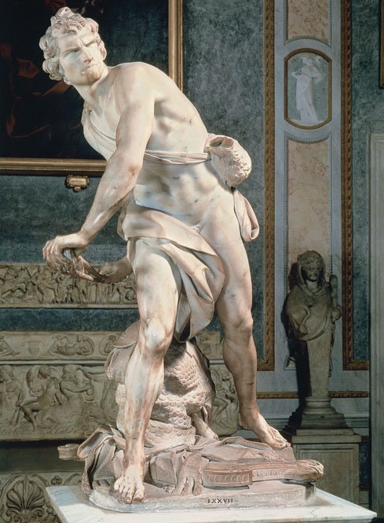
RENAISSANCE AND BAROQUE EUROPE CHAPTER 17 293
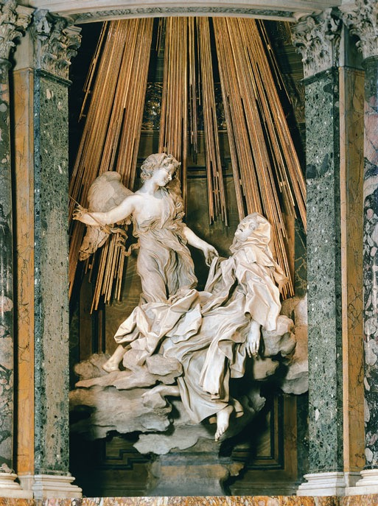
the work of Michelangelo and the Venetians. When Rubens returned north, he won increasing acclaim and patronage; being a sophisticated businessman, he enjoyed an aristocratic lifestyle. His work came to be in such demand by the nobility and royalty of Europe that he established a large studio with many assistants. Although Rubens was noted for the exuberant quality of his nudes, there was a tendency for everything in his paintings to take on a similar sensuality. His free brushwork influenced many painters.
In The Raising of the Cross (fig. 17.20), we see his interpretation of a religious subject, painted for an important Roman Catholic cathedral in his home- land. The composition is arranged along a diagonal anchored at the bottom right by the well-muscled fig- ure. This and other taut bodies in the work show the
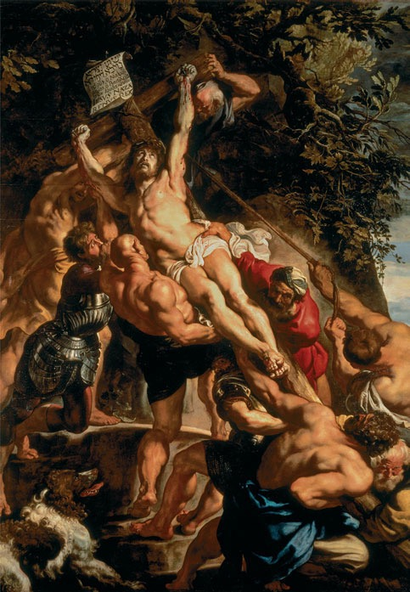
17.19 Gianlorenzo Bernini. The Ecstasy of Saint Teresa.
1645–1652. Detail of the altar. Marble. Life-size.
Cornaro Chapel, Santa Maria della Vittoria, Rome, Italy. Photograph: © Canali Photobank.
work The Ecstasy of Saint Teresa (fig. 17.19). It features a life-size marble figure of the saint and depicts one of her visions as she recorded it in her diary. In this vision, she saw an angel who seemed to pierce her heart with a flaming arrow of gold, giving her great pain as well as pleasure and leaving her “all on fire with a great love of God,”3 as she wrote in her autobiography. Bernini made the visionary experience vivid by portraying the moment of greatest feeling, revealing spiritual passion through physical expression. A skylight above provides dramatic lighting for the sculpture, and turbulent drap- ery heightens the emotional impact. Bernini’s depar- ture from the balanced, classical norm soon influenced artists throughout Europe.
Flemish painter Peter Paul Rubens, a renowned diplomat and humanist, was the most influen- tial Baroque artist in northern Europe. He studied painting in Antwerp, then traveled to Italy in 1600. During a stay of several years, he carefully studied
17.20 Peter Paul Rubens. The Raising of the Cross. 1610–1611. Oil on panel. One part of a
three-part work. 15 ́2 ̋ × 11 ́2 ̋.
Onze Lieve Vrouwkerk, Antwerp Cathedral, Belgium. Photograph: Peter Willi/Bridgeman Art Library.
294 CHAPTER 17 RENAISSANCE AND BAROQUE EUROPE
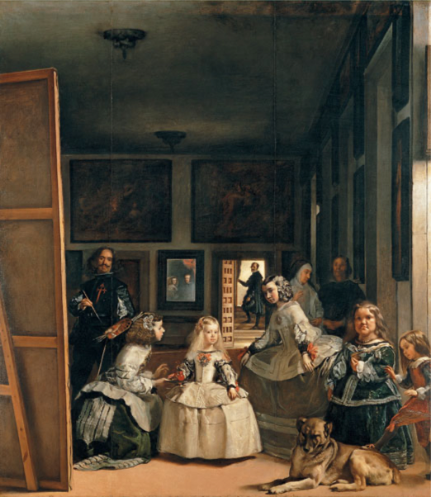
results of the artist’s recent visit to Italy, where he saw works by Michelangelo and Caravaggio. At the same time, there is a high degree of realistic detail in the foli- age and the dog at the bottom left that show Rubens’s Flemish heritage from Jan van Eyck and others. The action and drama in the work seem to burst out of the frame, led by the upward glance of Christ. This visual dynamism, extending the action of the work into the viewer’s space, marks this work as a Baroque painting.
Many artists worked on behalf of the Church during the Baroque period; some worked in the ser- vice of the nobility. The most innovative of these was the Spaniard Diego Velázquez, who spent most of his career in the court of Philip IV, King of Spain. Philip was a broad-minded monarch who took delight in his chief painter’s sometimes adventurous works. Such a painting is The Maids of Honor (fig. 17.21), in which Velázquez plays an elaborate game. At first it is unclear who the subject is, because the artist him- self stares out from behind a canvas, brush in hand. The maids of honor surround the king’s daughter, who stares coquettishly at us, as if expecting something. She seems to be the center of the composition, as she stands in the brightest light. Another courtier stands in an illuminated doorway in the background. Only when we see the mirror on the far wall, with the faces of the royal couple reflected in it, do we realize that this is a court portrait changed into a visual riddle. Velázquez painted a portrait of himself making a royal portrait! Like other Baroque works, this painting reaches out beyond its frame in a subtle dynamism of glance and image in which light and shadow play a major role.
We have seen that Baroque characteristics are found in art that depicts both religious and secular sub- jects. This was primarily because artists no longer relied wholly on the Church for their support; many worked for nobles and aristocrats. In the Dutch Republic, how- ever, a new type of art patron emerged in the seven- teenth century as a result of recently won independence and booming international trade—wealthy middle- class merchants and bankers, most of them Protestants. These new patrons enjoyed and invested in contempo- rary art. Favored subjects were the same ones preferred to this day: landscape, still life, genre scenes, and por- traits. Through Dutch painters, art became accessible and understandable in everyday terms.
17.21 Diego Velázquez. Las Meninas (The Maids of Honor). 1665. Oil on canvas. 10 ́5 ̋ × 9 ́.
Museo del Prado, Madrid, Spain. Photograph: akg-images/Erich Lessing.
View the Closer Look for Diego Velázquez’s Las Meninas on myartslab.com
We can see why Rembrandt remains one of the Western world’s most revered artists in his large work Return of the Prodigal Son (fig. 17.22). The story comes from the Bible: A disobedient son cuts him- self off from his family, demands his inheritance early, wastes it in disorderly living, and ends up in dire pov- erty. When he reaches the end of his rope, he returns to his wealthy father and asks for a job feeding the hogs. The father is not scornful or judgmental, rather the opposite. He tenderly welcomes the haggard and forlorn young man. Rembrandt portrays this touch- ing scene with great reserve and economy. We see the prodigal son’s ragged clothing, and the father’s gentle embrace. We also see standing at the right, hanging back guardedly, the father’s other son.
Rembrandt’s composition shows the influence of the Italian Baroque painters in its dramatic contrasts of light and dark. The story, however, is not of the mirac- ulous vision of a saint, as in Caravaggio’s Conversion of Saint Paul, but rather a miraculous restoration of affection between estranged people.
RENAISSANCE AND BAROQUE EUROPE CHAPTER 17 295
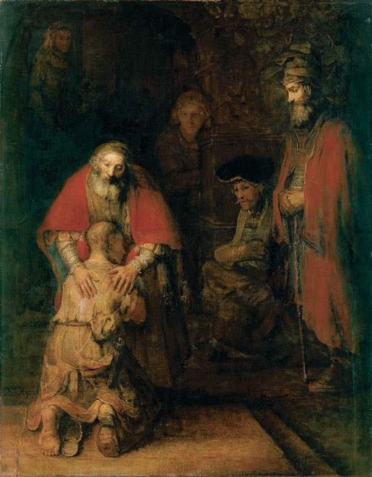
17.22 Rembrandt van Rijn. Return of the Prodigal Son. c.1668–1669. Oil on canvas. 8 ́8 ̋ × 6 ́8 ̋.
The State Hermitage Museum, St. Petersburg, Russia.
Rembrandt was also a printmaker of consider- able reputation. His many etchings show him putting the Baroque language of light and dark to good use in framing religious subjects, a common theme of his.
Jan Vermeer, another seventeenth-century Dutch painter, created genre paintings that raise daily life to a level of great solemnity. Unlike Caravaggio and Rembrandt, who used light for dramatic emphasis, Vermeer concentrated on the way light reveals each color, texture, and detail of the physical world. He showed immense passion for seeing, and apparent love for the visual qualities of the physical world.
Vermeer’s understanding of the way light defines form enabled him to give his images a clear, luminous vitality. Much of the strength of The Kitchen Maid (fig. 17.23) comes from a limited use of color: yellow and blue accented by red-orange, surrounded by neu- tral tones. The light has a mystical quality in this work; the act of pouring milk takes on the air of solemn ritual.
17.23 Jan Vermeer. The Kitchen Maid. c.1658. Oil on canvas. 18 ̋ × 161⁄8 ̋.
in which the subject is arranged by the artist on a tabletop, generally beginning with fruits or flowers, and often including other food items and domestic utensils. The term originated in the Netherlands, and Dutch artists were leaders in this field during the sixteenth and seventeenth centuries, as they painted elaborate still lifes celebrating the bounty of nature. Another important center was in Spain, where artists often isolated just a few items in dramatic light.
In the work of Juan van der Hamen we see influ- ences from both schools. In Still Life with Sweets and Pottery (fig. 17.24), the stark lighting and bare setting are typically Spanish, but the rich bowls of fruit and pastries show northern influence. The artist here cap- tured various textures of baskets, clay pots, and wood boxes along with the edible items. This work is also an interesting exercise in composition, as the artist created a rhythm of circular forms seen from various angles on the plain gray shelves.
During the Baroque period, French artists adopted Italian Renaissance ideas but made them their
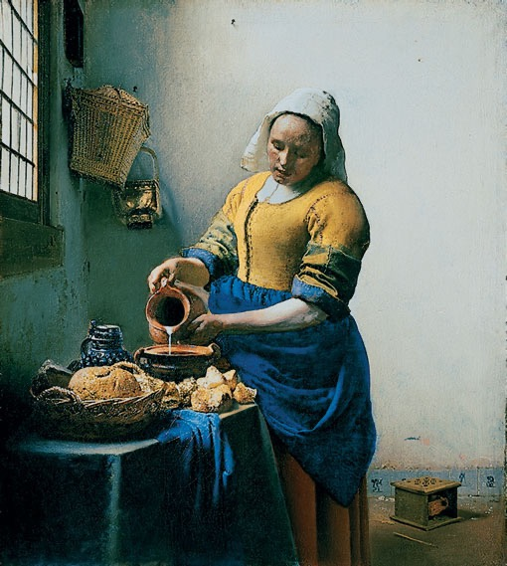
Still life painting enjoyed a new vogue during
the Baroque period as well. A still life is a painting Rijksmuseum, Amsterdam.
296 CHAPTER 17 RENAISSANCE AND BAROQUE EUROPE
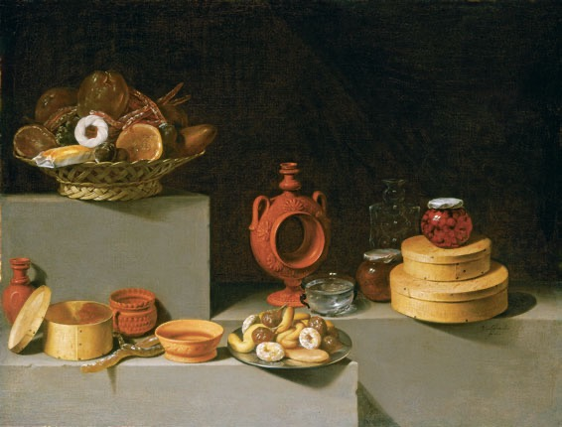
own. We can glimpse a clear view of Baroque aristo- cratic splendor in the architecture of the French royal palace of Versailles, built for King Louis XIV. The main palace and its gardens exemplify French Baroque architecture and landscape design (see fig. 2.17 for an overview). The Hall of Mirrors (fig. 17.25), at the heart of the palace, functioned like a stage set for the king’s entrances and exits. The hall appears doubled in width by the nearly solid wall of mirrors opposite the glass windows. Such glassworks were very expensive in that era, making the hall a display of opulence unique in Europe. Almost lost in the reflected splendor is the classical detailing in the pilasters and round arches. The ceiling is covered with paintings that depict the recent exploits of Louis XIV. At Versailles, Louis and his successors created a visual spectacle that supported their belief in the monarchy as the source of all power.
17.24 Juan van der Hamen. Still Life with Sweets and Pottery. 1627. Oil on canvas. 331⁄4 ̋ × 443⁄8 ̋.
National Gallery of Art, Washington D.C. Samuel H. Kress Collection 1961.9.75.
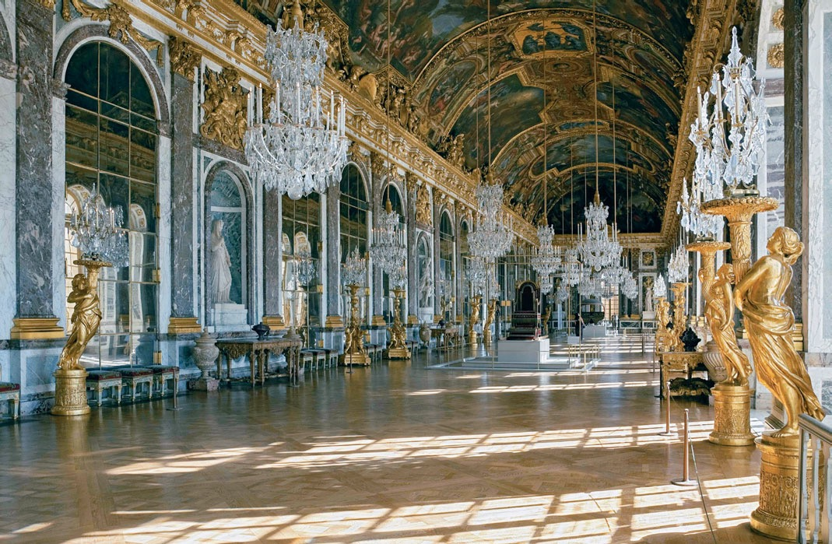
17.25 Jules Hardouin-Mansart. The Hall of Mirrors.
Versailles. Begun 1678. Length approx. 240 ́.
© Corbis.
Watch a video about the Palace and Park of Versailles on myartslab.com
RENAISSANCE AND BAROQUE EUROPE CHAPTER 17 297
ART FORMS US: PERSUASION
Inspiration
Versailles is one of the Western world’s clearest examples
of persuasive art, in which
its patron or creator tries to convince us of something
or influence our beliefs (in
this case, about absolute monarchy). But while some works of art, like the Hall of Mirrors at Versailles (see fig. 17.25), attempt to persuade us with their splendor and expense, others inspire us through more subtle means. Here we consider three works that attempt, through inspiration, to make the case that progress is a good thing.
Joseph Wright of Derby’s A Philosopher Gives a Lecture on the Orrery (fig. 17.26)
is a compelling piece of propaganda for a scientific worldview that was beginning
to dawn in the mid-eighteenth century and which would
reach greater fruition in the Enlightenment (see Chapter 21). An orrery, named after
the English earl that sponsored the first one, is a model of the solar system with the sun at its center amid the orbits of various planets. At the time this work was painted in 1766, scientific lectures and demonstrations were just entering a phase of popularity as public events, and Wright probably attended such lectures. In the painting he used the Baroque conventions of dramatic lighting. A lamp takes the place of the sun, while
a red-garbed professor who resembles the English scientist Isaac Newton describes the motion of the planets around it. The reactions of the spectators, which range from contemplative
before them, as other members of the party hack out the trail immediately ahead. Below is a horizontal panel depicting the Pacific shore, between portraits of explorers Daniel Boone and William Clark.
Leutze wrote of his intent in the work: “To represent as near and truthfully as the artist was able, the grand peaceful conquest of the great west.”4 We know, of course, that
the conquest of the west was far from peaceful, and that
the family groups seen here generally traveled on paths already established. Still, this work’s intent to inspire is clear enough that the United States government commissioned Leutze to paint a larger version in a stairwell of the national Capitol in Washington, D.C. There it exercises its influence, silently but vividly encouraging the belief that the “Manifest Destiny” of the United States
is to occupy the land from the Atlantic to the Pacific.
Tall buildings can be inspirational, “proud and soaring things,”5 as the architect Louis Sullivan wrote. Vladimir Tatlin’s Monument
to the Third International
(fig. 17.28) is probably the most inspirational building never built. The Third
17.26 Joseph Wright of Derby.
A Philosopher Gives a Lecture
on the Orrery. 1766.
Oil on canvas. 58 ̋ × 80 ̋.
Derby Museum and Art Gallery. akg-images/Erich Lessing.
to awestruck, give us a glimpse of this work’s intended impact: In the (artificial) glow of the sun/lamp, they experience scientific enlightenment.
This work thus inspires us to contemplate the virtues of scientific inquiry and the expansion of knowledge.
The westward expansion
of the United States in the nineteenth century is an established part of the national mythology, and the German- born painter Emanuel Leutze helped to put it there, with paintings such as Westward the Course of Empire Takes Its Way (fig. 17.27). In this work a group of settlers has reached the Continental Divide, and they gaze out at the vast expanse of land with its seemingly endless possibilities
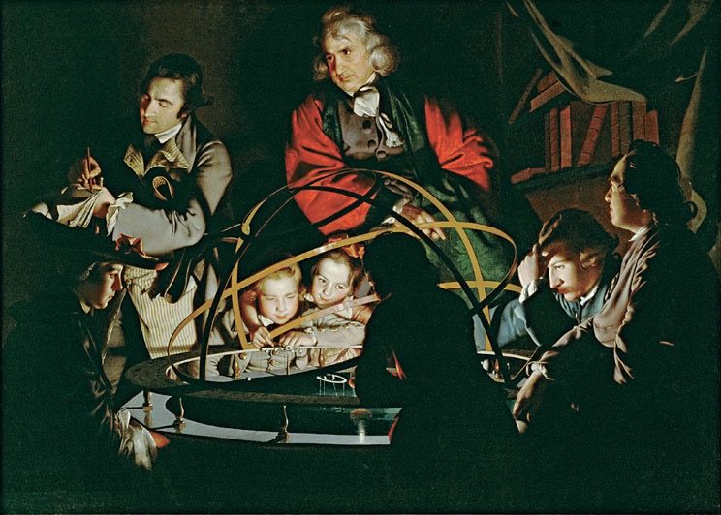
298 CHAPTER 17
RENAISSANCE AND BAROQUE EUROPE
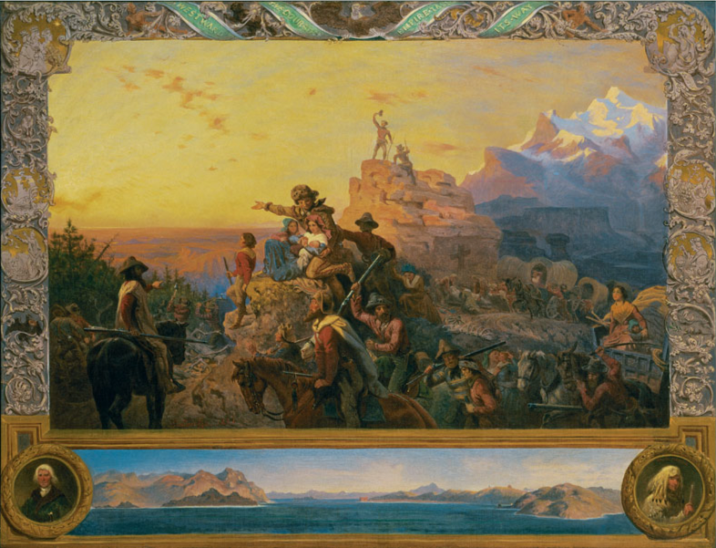
17.27 Emanuel Leutze. Westward the Course of
Empire Takes its Way. 1860. Mural study. U.S. Capitol. 331⁄4 ̋ × 433⁄8 ̋.
Smithsonian American Art Museum Washington, D.C. © 2013. Photo Smithsonian American Art Museum/ Art Resource/Scala, Florence.
17.28 VladimirTatlin.
Model for Monument to
the Third International.
1919. Photograph.
The Bridgeman Art Library.
International was a new party founded by revolutionary leader Vladimir Lenin in 1919 to spread Communism around the world. Originally planned for a height of over 1,300 feet, this twisting metal structure was intended to symbolize
the technological prowess of the new Communist Russia that was born with the 1917 revolution. The helix-shaped frame houses three glass buildings that were intended for use as a people’s assembly hall, offices, and a radio- loudspeaker broadcasting news and inspirational messages. These pavilions were designed to rotate at varying speeds: once a
year, once a month, and once a day.
Tatlin conceived the tower
to compete with the recently completed Eiffel Tower
in Paris, but his tower
would be more useful to society, a constant source
of encouragement to all
who passed by, as well
as a functional structure. Its realization at the time, when Russia was still suffering from post-revolutionary shortages and political unrest, was certainly impossible. However, models of the tower were built from time
to time for exhibitions and even for carrying in parades. Thus, though the world never saw the full-sized version, models and miniatures inspired the Soviet people
at various times.
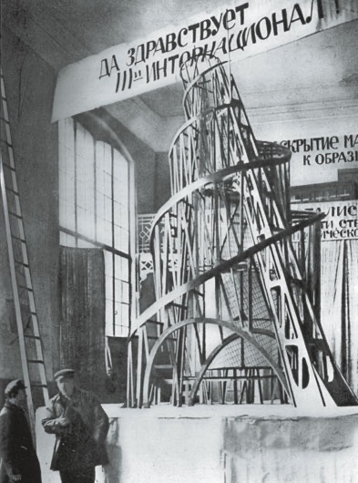
RENAISSANCE AND BAROQUE EUROPE CHAPTER 17 299
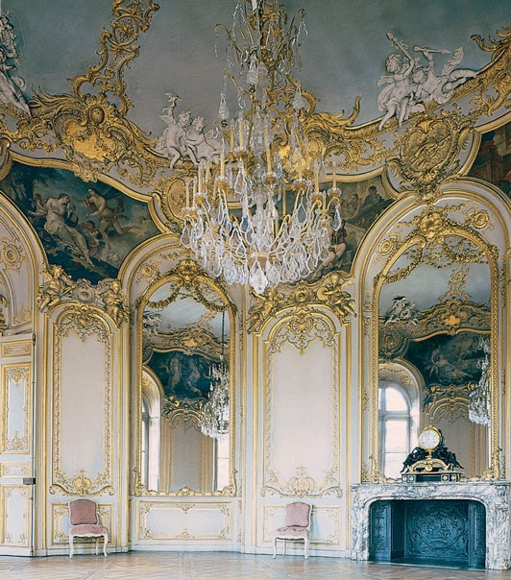
17.29 Germain Boffrand. Salon de la Princesse. Hôtel de Soubise, Paris. Begun 1732. Hirmer Fotoarchiv, Munich, Germany.
Rococo
In the middle years of the eighteenth century in France, the heavy, theatrical qualities of Italian Baroque art gradually gave way to the decorative Rococo style, a light, playful version of the Baroque. Designers copied the curved shapes of shells for elegantly paneled inte- riors and furniture, and they influenced the billowing shapes later found in paintings. The arts moved out of the marble halls of palaces such as Versailles and into fashionable town houses (called hôtels) such as the Hôtel de Soubise (fig. 17.29).
THINK BACK
- What technical advances in art helped make the Renaissance possible?
- How do northern Renaissance paintings differ from their Italian counterparts?
- Who were the three major client groups that commissioned Baroque art?
The enthusiastic sensuality of the Rococo style was particularly suited to the extravagant and often frivolous life of the French court and aristocracy. Some of the movement, light, and gesture of the Baroque remained, but now the effect was one of lighthearted abandon rather than dramatic action or quiet repose. Rococo paintings provided romantic visions of life free from hardships, in which courtship, music, and festive picnics filled the days.
We clearly see the aristocratic life of ease and dal- liance in Jean-Honoré Fragonard’s painting Happy Accidents of the Swing (fig. 17.30). A well-dressed and idle young woman, attended by a dimly visible bishop, swings in a garden. At the lower left, a youth hides in the bushes and admires her. The story line of the work is provided by her flying shoe, which has come off and will soon land in the young man’s lap. Fragonard learned the lessons of the Baroque well, as we can see in the off-balance composition arranged along the diagonal, and the contrasts of light and dark visible in the lush garden. But Baroque drama gives way here to the sensual abandon and light-as-air subject matter of the Rococo at its best.
Or worst. The next generation of French artists and intellectuals would rebel against the social irre- sponsibility portrayed in this type of art, which they saw as merely fluffy. The Enlightenment was already breaking out across Western Europe, and its new ideas of social equality and scientific inquiry would soon shake European culture to its core.
Study and review on myartslab.com
TRY THIS
Compare the Renaissance David by Michelangelo (fig. 17.9) with the Baroque David by Bernini (fig. 17.18). In your opinion, which is the
better work of art, and why?
300 CHAPTER 17 RENAISSANCE AND BAROQUE EUROPE
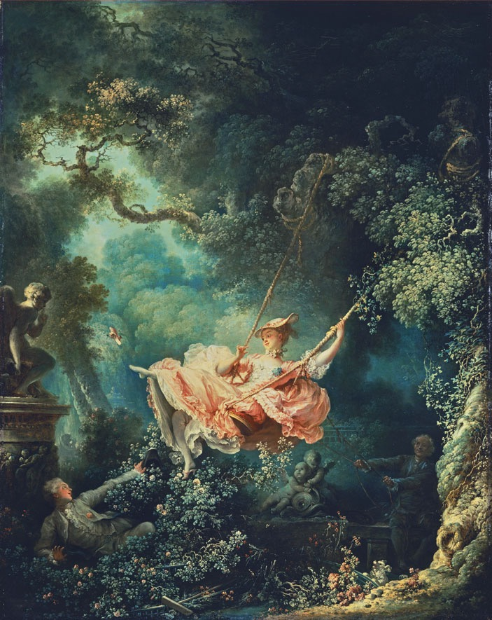
17.30 Jean-Honoré Fragonard. Happy Accidents of the
Swing. 1767. Oil on
canvas. 317⁄8 ̋ × 251⁄4 ̋.
The Wallace Collection, London. The Bridgeman Art Library.
KEY TERMS
Baroque – the seventeenth-century period in Europe characterized in the visual arts by dramatic light and shade, turbulent composition, and pronounced emotional expression
genre painting – a type of art that takes as its subject everyday life, rather than civic leaders, religious figures, or mythological heroes
humanism – a cultural and intellectual movement during the Renaissance, following the rediscovery of the art and literature of ancient Greece and Rome
Renaissance – the period in Europe from the late fourteenth through the sixteenth centuries, characterized by a renewed interest in human-centered classical art, literature, and learning
Rococo – a style used in interior decoration and painting in France and southern Germany in the eighteenth century, characterized by small-scale and ornate decoration, pastel colors, and asymmetrical arrangement of curves
still life – a painting of inanimate objects, such as flowers, fruit, other food items, and domestic utensils
RENAISSANCE AND BAROQUE EUROPE
CHAPTER 17 301

